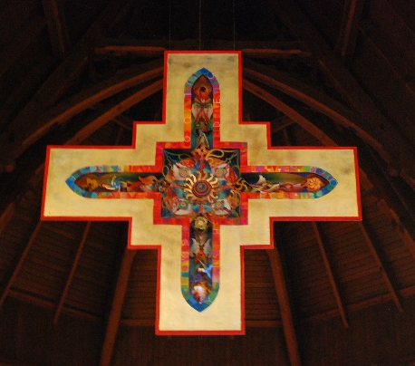
St. Paul’s Anglican Church
59 Toronto Street South
Uxbridge Ontario L9P1H1 Canada

Phone: 905-852-7016
Email address: stpaulsuxbridge@yahoo.ca
Website: http://www.stpauls-uxbridge.ca/

The Reverend Canon Mark Kinghan, Priest in Charge

Pastoral Process for Re-marriage Following Divorce

Until the 1970s, the Anglican Church did not entertain the re-marriage of divorced people for what it considered sound theological reasons. At that time, it became clearer that there was a need for the church to respond to the ever-increasing requests for remarriage.

The “Matrimonial Commission” came into being at that time. This process involved the priest meeting with the couple who had spent time reflecting on questions related to the past marriage and children, the present relationship, and the future marriage. The forms, along with a recommendation from the presiding priest, were then sent to a commission of individuals in the diocese who oversaw the implementation of the national church’s canons on this issue. The primary purpose of the “Matrimonial Commission” was (a) to ensure that there was a valid divorce; (b) to ensure that the individual and couple had dealt with any residual issues of the past relationship; and (c) to ensure that any children were appropriately considered and secure. Over time, this process too became outdated.

In 2001, the canons of the national church gave each diocese the option of not requiring couples to go through the formal matrimonial process. However, individual clergy were encouraged to continue with a process that was pastoral and preserved the desire for the individuals to reflect on the past, present, and future.

Please take the time to think and discuss seriously the reflection questions that follow. If they raise issues for you as individuals or as a couple, take the time to talk to each other and others who may be a support to you. This is a healthy way to enter into your new relationship in a way that will make it meaningful and lasting.

Names
Date Set for Marriage

Information for Divorce

First Couple

Names
Date of Marriage
Place of Marriage
Your Marital Status Prior
Date Separated Permanently
Decree Absolute Date

Second Couple (if both parties are divorced)

Names
Date of Marriage
Place of Marriage
Your Marital Status Prior
Date Separated Permanently
Decree Absolute Date

Please attach a copy of the Decree(s) Absolute.

Name

1. Please outline your understanding of:

- the causes that led to the breakdown of your marriage

- your attempts to seek help and reconciliation

2. Please give the names, ages, and custody and living arrangements for any children born to your previous marriage.

3. How do the children get along with the parent who does not have custody?

Name

1. Please outline your understanding of:

- the causes that led to the breakdown of your marriage

- your attempts to seek help and reconciliation

2. Please give the names, ages, and custody and living arrangements for any children born to your previous marriage.

3. How do the children get along with the parent who does not have custody?

How long have you known each other?
Are you living together?
If yes, for how long?

Please reflect on what you learned from your previous experience of the broken marriage(s) that will be helpful in sustaining this new relationship.

Please reflect on the reasons you have for your confidence that your proposed marriage will be stable.

What is the attitude of each of the children of your previous marriage(s) to your proposed marriage?

How do you see each of these children relating to both of you in your married life?

Taking into account any difficulties and opportunities you foresee, how do you anticipate developing and sustaining your new family life?

My responses to each of the above questions are complete and true.

Signatures

Date

