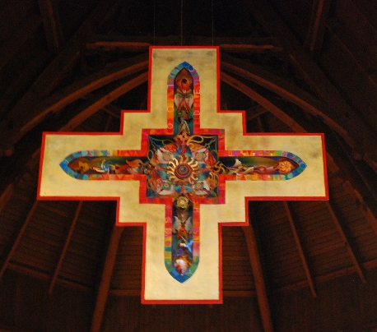
St. Paul’s Anglican Church

59 Toronto Street South
Uxbridge Ontario L9P1H1 Canada

Phone: 905-852-7016
Email address: stpaulsuxbridge@yahoo.ca
Website: http://www.stpauls-uxbridge.ca/

The Reverend Mark Kinghan, Priest in Charge

Sacrament of Marriage Form
Fees
Weddings at St. Paul’s |  |  | Offsite Weddings
 | Parishioners | Non-parishioners |  | Parishioners | Non-parishioners
Donation to St. Paul’s | $250 | $500 | Donation to St. Paul’s | $250 | $500
Clergy | $300 |  | Clergy | $500
Organist | $200 (plus appropriate increase for additional music)
St. Paul’s Wedding Co-orinator | $50
* Please note that other fees may be applicable and that fees may be amended from time to time.
** Please note that fees can be reasonably adjusted if they provide a financial hardship for the couple.

Date |  | Names:
Time
Wedding Rehearsal  Date & time |  | Number in Wedding Party:  Ages of Children in wedding party:
Licence Number |  | Date received
Dates for pre-marriage Interviews | 1.  2.  3.

Holy Eucharist | Yes No
Bell Ringer | Yes No
Flowers | Yes No  Contact made with St. Paul confirmed _______
Scripture Readings & Readers

Groom Full Name:
Marital Status Unmarried  Widowed  Divorced |  | If divorced in Canada, Court File Number  (Please provide a copy of final divorce papers)
Address |  | Telephone  Home:  Cell:
E-mail Address
Date of Birth |  | Place of Birth
Citizenship |  | Occupation
Home Church |  | Denomination
Baptism Yes No |  | Denomination
Confirmation Yes No |  | Denomination
Father’s Full Name |  | Place of Birth
Mother’s Full Name |  | Place of Birth

Bride Full Name:
Marital Status Unmarried  Widowed  Divorced | If divorced in Canada, Court File Number  (Please provide a copy of final divorce papers)
Address | Telephone  Home:  Cell:
E-mail Address
Date of Birth | Place of Birth
Citizenship | Occupation
Home Church | Denomination
Baptism Yes No | Denomination
Confirmation Yes No | Denomination
Father’s Full Name | Place of Birth
Mother’s Full Name | Place of Birth

Address following the marriage:

